Week 8 assignment is, inevitably, about Regular Expressions and OpenRefine
Upload a text file or a PDF with your answers/solutions to the problems below. Beware of making the submission legible and understandable to another reader; for example, consider using the "Save regex" functionality in regex101.com, which allows you to create a link out of your solution and share the link for easy use by your colleagues. Remember that you can elaborate solutions in groups, but need to submit individually.
- What regular expressions do you use to extract all the dates in this blurb: http://bit.ly/regexexercise2 and to put them into the following format YYYY-MM-DD ?
https://regex101.com/r/xhR7p5/1
Kode: (\d+).(\d+).\s?(\d+)
Man skriver koden i ind i regex, og skriver i substitution: $3-$1-$2 for at få datoen til at stå i rigtig rækkefølge
- Write a regular expression to convert the stopwordlist (list of most frequent Danish words) from Voyant in http://bit.ly/regexexercise3 into a neat stopword list for R (which comprises "words" separated by commas, such as http://bit.ly/regexexercise4 ). Then take the stopwordlist from R http://bit.ly/regexexercise4 and convert it into a Voyant list (words on separate line without interpunction)
Voyant Stopword list->R Stopword list
https://regex101.com/r/fZHbie/1
Kode: ([a-zæøå0-9éü’.?]+)(\n)?
Man skriver koden ind i regex, og skriver nede i substitution: "$1", for at få en voyant stopliste til at passe ind i R stopword List
R Stopword list -> Voyant Stopword List
https://regex101.com/r/Qz546I/1
Kode: (["])([a-zæøå0-9.,éü’]+)(["])([,])?([ ])?
Man skriver koden ind i regex, og skriver nede i substitution: $2\n for at forvandle R stopword liste til en Voyant stopword liste
- Does OpenRefine alter the raw data during sorting and filtering?
- Det gør den ikke
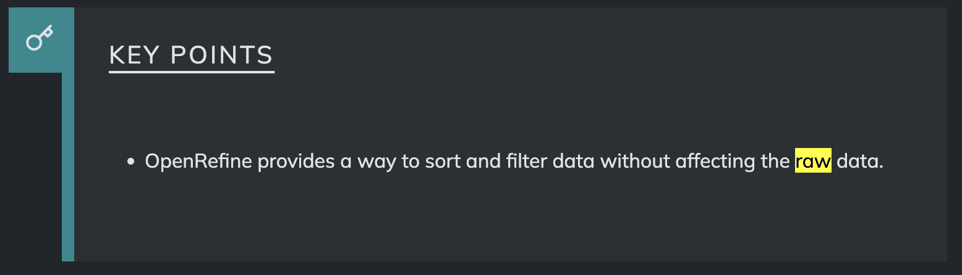
https://datacarpentry.github.io/openrefine-socialsci/03-filter-sort.html
- Fix the interviews dataset in OpenRefine enough to answer this question: "Which two months are reported as the most water-deprived/dryest by the interviewed farmer households?"
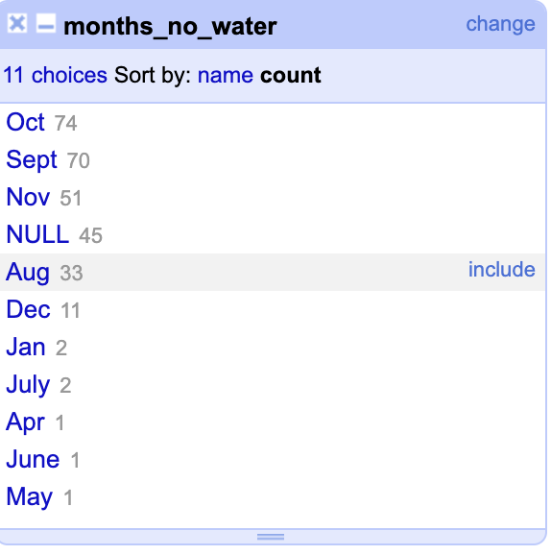
Jeg lavede en custom facet under month_no_water mod koden value.split(";"), for at få denne liste, derefter sorterede jeg efter “count” og ikke “name”
- Real-Data Challenge: What are the 10 most frequent occupations "erhverv" among unmarried men or women of 20-30 years in 1801 Aarhus census dataset? (hint: first select either men or women to shrink the dataset to a manageable size, then filter by age, and then use merging to cut the erhvervvariation ruthlessly.)
Jeg sorterede så jeg kun fik ugifte mænd ind i arket, derefter satte jeg Cluster igang med at rette fejl i ordene, så som National Soldat og nationalsoldat bliver til National Soldat, så de bliver talt sammen i stedet for hver for sig
